**CHAPTER ONE**

**INTRODUCTION**

This chapter presents preliminary information about the topic, it aims to gain interest in the reader on the topic. The sub section are as follows, background, statement of the problem, aims and objectives, scope and limitations

**1.1 Background of the Study**

When connected to an Ethernet cable, a cable tester tells if the cable is capable of carrying an Ethernet signal. If the cable carries the signal, this indicates that all the circuits are closed, meaning that electric current can move unimpeded through the wires, and that there are no short circuits, or unwanted connections, in the wire. cable testers vary in complexity and price, but a basic tester consists of a source of electrical current, a measuring device that shows if the cable is [good](https://www.projectplus.com.ng/tag/good/), and a connection between the two, usually the cable itself.

Connectivity refers to a topological nature of cyberspace or collections. Intuitively speaking, connectivity is connected without interruption (Yidan, 2013). Connectivity analysis is to analyze whether two points are connected according to the specified starting and ending nodes; or to determine whether multiple points are communicating with each other according to the specified multiple points. In computer science, connectivity analysis mainly analyzes the connectivity between multiple points in a network. With the popularization of the network, network cables are located in every corner of daily life. It is the most important part of network wiring. Therefore, network cables are one of the essential devices for connecting to the network (Jin, 2013). The most direct impact is related to network continuity and network communication quality. When the computer cannot connect to the Internet, the network cable is often the first object of suspicion. The first response is if the network cable is broken and caused a failure. Generally speaking, there are three main problems caused by network cable failures: connection, performance, and continuity (Yanhang et al, 2013). To judge whether the network cable is normal we use a network cable tester to determine whether the network cable is normal. Similarly, in the network cabling project of the local area network, a large number of network cables need to be laid, and each of them needs to be tested, that is, the network cable connectivity test (Binbin & Feng, 2018)]. It is often necessary to use a network cable tester to check the connection of the network cable and the sequence of the cables. When the network cable, especially the 8-core cable, is inserted, it is troublesome to determine whether the connection is correct. Therefore, if you can test the quality of the network cable in advance and complete the connectivity test of the network cable in advance, the network efficiency will be greatly improved. Currently, the network cable testers on the market are expensive and the test efficiency is low.

In view of the above problems, a cheaper test circuit capable of testing with good efficiency is designed in this project, which aims to provide an efficient method for testing network cables, that will greatly improve the efficiency of network cable testing.

**1.2 Statement of the Problem**

The twisted pair cable tester uses LED pattern to tell the user the type of cable being tested. So, if the user is not knowledgeable with the cable standards or configuration, the user won’t be able to make out anything from the output of the cable tester. This becomes a problem because only users with the technical knowhow will be able to read and understand outputs from the cable tester. This work aims at designing a system that will make any user, including a lame man, understand the type of cable being tested. The design of this work will include light emitting diodes that will be used to tell the user if the cable is cross, straight or broken.

**1.3 Aim and Objectives**

The aim of this project is to design and construct a twisted pair cable testing hardware. The hardware will use an Arduino microcontroller and light emitting diodes that will display certain characters, telling the user if the cable is straight, cross or broken so the work is to realize a cable tester is to be used to verify that all of the intended connections exist and that there are no unintended connections in the cable being tested. When an intended connection is missing it is said to be “open”. When an unintended connection exists it is said to be a “short” (a short circuit). If a connection “goes to the wrong place” it is said to be “miswired” (the connection has two faults: it is open to the correct contact and shorted to an incorrect contact)

The objectives of this project are:

1. To design the system that will be used for cable testing.
2. To write a C++ program that would enable the microcontroller test the cable.
3. To construct and test the system.

**1.4 Scope of the Study**

This project will deal with only twisted pair network cable only. It will not in any way consider other types of cable. It will be powered by battery to make the system portable and easy to operate. It will use visual display to serve as interface for the user to enable easy interpretation. The hardware will involve a microcontroller to reduce component count and raise the reliability of the system.

**CHAPTER TWO**

**LITERATURE REVIEW**

The twisted cable tester consists of several subsystems interconnected to perform a single purpose. The sub-systems are the connectors, the microcontroller and the display section. This section covers the different approaches proposed in numerous works by different authors to solve the problem of network cable testing.

**2.1 Related Work**

Raj Kumar (2014) Designed and constructed a RJ cable tester. In this project, a microcontroller was used to control all the transfer voltage and one LCD to display the messages. We use 89s52 controller, which is a family member of the 8051 controllers. 2 lines and 16 characters on the LCD was used to display the message on the screen. Along with the LCD and microcontroller, we use total 16 LEDs to check the continuity of wire. Out of 16 LEDs, 8 LEDs are for the input signal and 8 for the output signal. 5 volt regulated supply for the whole circuit. For this, which use step down transformer to step down the voltage or 7805 regulator to reduce the voltage from 9 volt to 5 volt dc. It was shown that how we can check the LAN or any other cable with the smart point to point checking method. In this method of wire testing, we pass voltage from one end to another end to each wire. If the wire passes the voltage successfully, then connected LED is ON and LCD shows a message on screen, so microcontroller checks all the eight wires one by one and shows the result on LCD. If all the points are okay, then LCD display an ‘OK’ message. If even a single wire is not transferring the voltage, then LCD shows a ‘NOT OK’ message. This tester is a very simple two-piece unit that allows one person to check the operation of 10Base-T cables with a minimum of fuss. Both end of the assembled cable is plugged into each of the tester units.

Bhaskar (2017) worked on an RJ45 cable tester. The work Described here is a simple RJ45 cable tester circuit which can be used for testing the RJ45 network cables. The circuit can check both straight-through and crossover-type RJ45 network cables. This is a low-cost tester designed using easily available components. Fig. 1 shows the difference between straight-through and crossover network cables. The tester also indicates the type of cable under test with different sequences in which LEDs glow for both types of cables. the circuit diagram of RJ45 cable tester. The circuit makes use of easily available components such as timer NE[555](https://www.electronicsforu.com/resources/learn-electronics/555-timer-working-specifications) (IC1), decade counter [CD4017B](http://www.ti.com/lit/ds/symlink/cd4017b-mil.pdf) (IC2) and a few other components. IC1 is a popular timer, wired in astable multivibrator mode generating output pulses of around 1Hz at pin 3.

[Julian Horsey](https://www.geeky-gadgets.com/author/jhorsey/) (2021) Developed an RJ 45 cable tester using Arduino which allows diagnosing the type and integrity of both USB and RJ45 network cables and will identify the exact wiring configurations as well as diagnose broken wiring, and plug pin connections. Test over 10 cables types using RJ45, USB B/B3, USB A/A3, USB C, USB Mini, USB Micro/Micro3. Remove uncertainty and know for sure whether that cable is causing your project to fail by quickly testing its integrity using the awesome Arduino cable tester. The touchscreen menu allows you to select from Auto Detect Mode and Manual Mode for a deeper diagnosis and is based on the popular Instructorless project for the Arduino Cable Tracer published sometime back and also powered by an Arduino Mega 2560.

[Arian](https://www.electroschematics.com/author/admin/) (2010), designed a Cable tester for Network cable type RJ45 using discrete components. Hi design is a multifunction RJ45 network cable tester. In the design of the network cable (RJ45) and telephone (RJ11) tester. It works for network, telephone, cable with RJ45 half “Registered Jack” plug immediately indicate whether a crossover network cable or straight, flashing a yellow or green LED. If something is broken or if you press the button, the tester is in line with the wire test. The top RJ45 connector sends signals to each of its eight legs. The lower RJ45 connector receives signals from the top RJ45 connector created by the wire. When the red LED above the orange light LED bar shows the pins in the top RJ45 connector sends a test signal, and when the bottom of the red LED illuminates orange LED bar indicates which of the eight dioceses of the bottom RJ45 connector signal receives in this state where the wire is broken or not connected, none of LEDs in the LED bar will light up orange. His design was cheap and reliable using common technology. It is cheap and easy to use.

According to Nariman (2020) who design and implemented a smart modern network tester uing AI. This project was able to achieve full communication between all devices using RJ45 cable by bypassing faulty lines using intelligent protocol. However, it was able to detect the faulty and type of line used through the selection of routers and switches to achieve the desired purpose.

According to Prof. R. Kakari, et. al, there is no such device that can perfectly test a cable for its working condition. Harnessed cables are often short circuited, open circuited or have interchanged connections. This system provides the best solution to these problems. It is time efficient, requires less manpower and a general purpose system. Testing for intermittent in cable and harness assemblies. There are three basic problems that occur in wire harnesses: opens, shorts and mis-wires. Since wires generally don’t change location by themselves, intermittent shorts and opens are the problem. Intermittent Shorts means failures in insulation between conductors that should be isolated. Intermittent opens/high resistance connections mean failures in the continuity of a conductor. Intermittent problems in the wire. The proposed work is based on CAN protocol but instead we are using simpler protocol, SPI protocol. (Yiyong Lin *et al, 2020*) Deals with continuity testing of the backplanes in production which would be tedious and error prone without an automated and standard test infrastructure. From this literature we have adopted testing methodology of cables. (Yiyong Lin *et al, 2020*). Presents a platform which deals with the implementation of certain of serial protocols presented by a low power 32-bit ARM RISC processor LPC2148. This platform is also useful for students of different disciplines to work with different serial protocols, which helps them in interfacing of sensors, memory ICs, analog subsystems and so on. We have studied the serial peripheral interface protocol and implemented the same in our device.

Yiyong et al, (2020). designed a system for network cable testing. The simple network cable tester can only test one network cable at a time. When multiple network lines need to be tested, there are problems such as a long time, low accuracy, prool efficiency, and unable to display visually. A multi-network test circuit is developed and designed based on the principle of network cable testing on this paper. The principle of the simple network cable tester is briefly analyzed. The overall design idea, circuit design, and working principle of the LAN connectivity test circuit are explained in detail. The circuit characteristics are summarized. The actual application verification is performed during the management and maintenance of the unit LAN. The application results show that: this circuit has the characteristics of stable operation, simple operation, safety and reliability, convenient maintenance, and intuitive display. It improves the speed of network cable testing, increases the visual display of test results, improves the efficiency of network cable testing, and has achieved good application results.

**2.2 Theoretical Review**

Twisted pair cables, otherwise known as RJ45 or Ethernet cables are used to network computers using a router or a switch. They are also used, directly, to connect two computers so that information can be shared between both computers.

These cables are twisted and are in pairs of 4 as shown in figure 1.1.

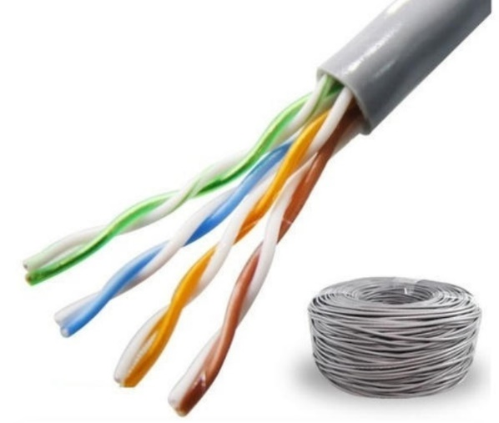

Figure 1.1: Twisted Pair Cable (source: Changzhou Alco International CO.)

To connect these cables to a switch, router or computer, an RJ45, 8 pin male connector is employed. The cable will be unpaired and carefully slipped into the connector to match its 8 pins and crimped using a crimper. Before crimping is done, the cable is unpaired and rearranged according to existing cable standards which are the TIA-568A or TIA-568B standard (dipol, 2020). Figure 1.2 shows an RJ45 male connector and figure 1.3 shows the twisted pair cable standards.

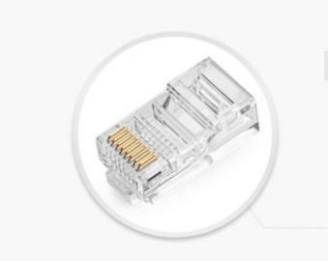

Figure 1.2: RJ45 male connector (Source: IndiaMart)

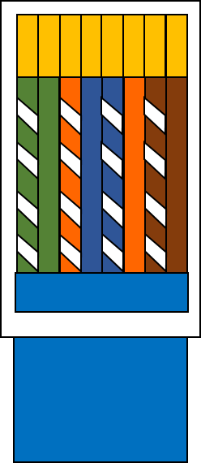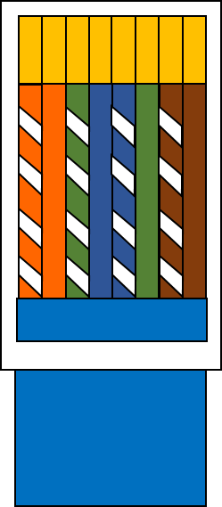

TIA-568A

TIA-568B

Figure 1.3: Twisted Pair Cable Standards

After crimping, the cable has to be tested using a cable tester to ascertain if the crimping was properly done or if the proper cable standard was followed or if any of the cable is broken.

To test the cables, both end of the cables are inserted into RJ45 female connector of the cable tester.

From figure 1.3 above there are 8 pins present per cable, if the cables are coded according to the table 1.1 below, then when the cable is inserted into the cable tester the pattern of LED light that can be seen is shown in figures 1.4 and 1.5.

Figures 1.4a through 1.4h gives the LED light pattern for straight through cable (both standards) while figures 1.5a through 1.5h gives the LED light pattern for cross cable.

Table 2.1: Color codes for twisted cable

|  |  |
| --- | --- |
| **Color** | **Code** |
| White green | 7 |
| Green | 6 |
| White orange | 5 |
| Blue | 4 |
| White blue | 3 |
| Orange | 2 |
| White brown | 1 |
| Brown | 0 |

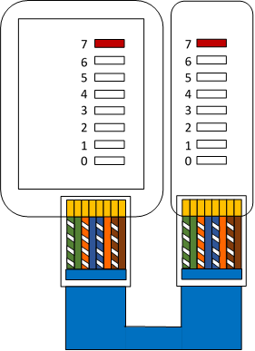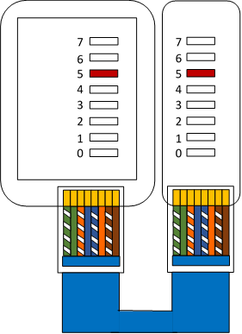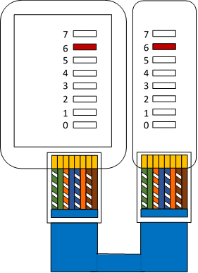

c

b

a

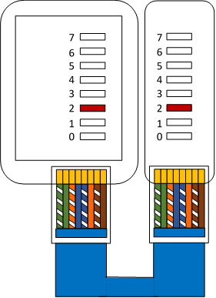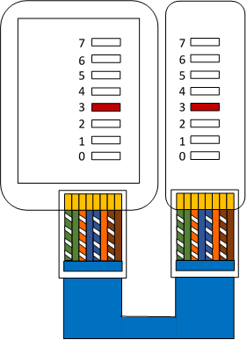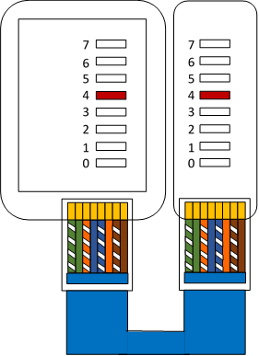

f

e

d

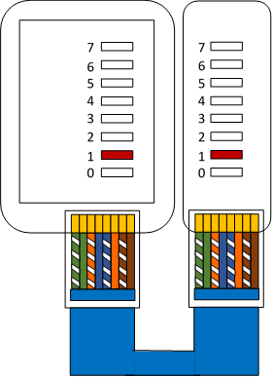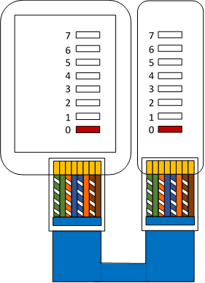

Figure 1.4: a to h depicts LED pattern for straight through cable

h

g

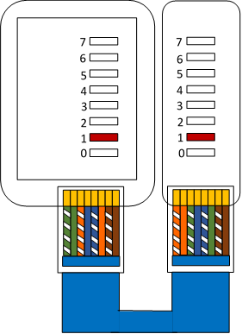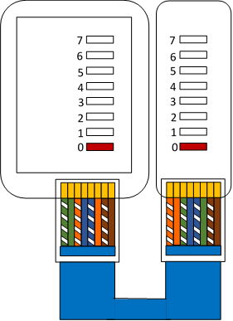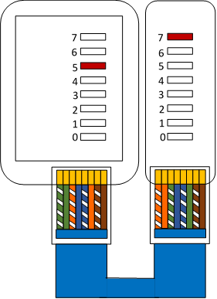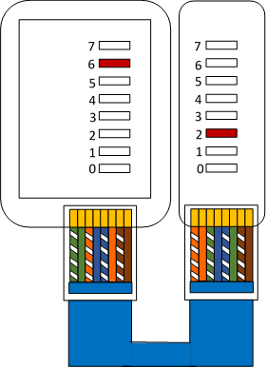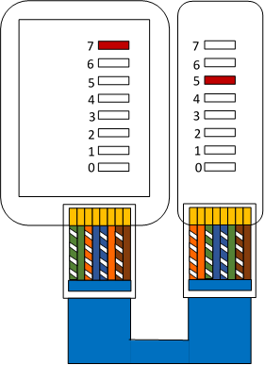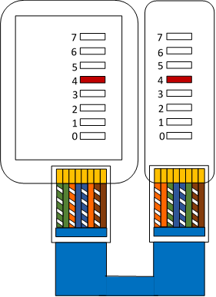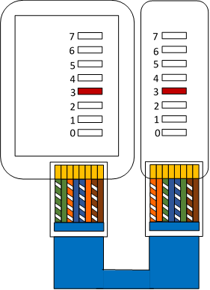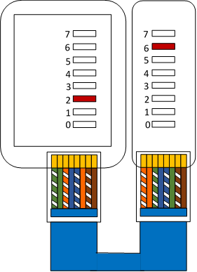

h

g

f

e

d

c

b

a

Figure 1.5: a to h depicts LED pattern for cross cable

**2.3 Cable Performance Test Parameters**  
i) Length  
Length is defined as the physical or sheath length of the cable. It should correspond to the length derived from the length marking commonly found on the outside jacket of the cable. Physical length is in contrast to electrical or helical length, which is the length of the copper conductors. Physical length  
will always be slightly less than electrical length, due to the twisting of the conductors [Arian](https://www.electroschematics.com/author/admin/), P (2010) .  
In the test, there is a limit which must not be exceeded. This limit is equal to 361 ft.

ii) Propagation is z nanoseconds  
per meter (worst case allowed is 5.8 ns/m as illustrated in ISO/IEC 11801). A 100-meter cable might have a delay equal to 500 ns (worst case allowed is 580 ns/m).

**References**

Yidan Shen. (2013) Concise Mathematical Dictionary [M]. Beijing Institute of Technology Press, Beijing.

Binbin Dangle Feng, etc. (2018) An Easy–to-use Network Test Testing-assist[J]. Rural Electrician, No. 08: 34.

Jin Wang. (2013) Design of a New Type of Network Cable Tester [J]. Science and Technology Windows, No. 28: 258～259.

Yanhang Zhang, Meng Yang, etc. (2015) Development and Simulation of Network-to-wire Tester[J]. Technology and Market. Vol 22, No. 12:24～26.

Raj k. (2014). Design of a microcontroller based RJ cable tester with LCD display. Sanket Gupta

Publications. Isue 5: 3-12-16 sanket.kinghrt@gmail.com

Bhaskar k. (2017) . Design and Construction of an RJ45 cable tester. Beijing Institute of

Technology Press, Beijing. International journal of emerging technology. IJET 8(5-7);12-15

[Julian Horsey](https://www.geeky-gadgets.com/author/jhorsey/) (2021). Development of an RJ 45 cable tester using Arduino. Electronic design

magazine Publication. Issue 11-volume 2-2021

[Arian](https://www.electroschematics.com/author/admin/), P (2010). Design and construction of a Network (RJ45) cable tester. Journal of industrial

research and application. JIRAA. 155B, 195-200.

Nariman K. (2020). Design of an intelligent network cable an type tester using artificial

intelligence. Presented at Neumann conference on artificial intelligence. Genève. Tukwo 7th October 2020

Yiyong Lin1*, Lei Lin2 and shibin Hu1(2020). Design and Realization of a LAN Connectivity

Test Circuit. ICSP 2020 Journal of Physics: Conference Series 1544 (2020) 012078 IOP Publishing doi:10.1088/1742-6596/1544/1/012078